**WORKSHEET 6**

**Student Name: ANMOLPREET SINGH UID:** 22BCS15759

**Branch:** BE-CSE **Section/Group:** 22BCS_NTPP-602-A

**Semester:** 6th  **Date of Performance:** 20/02/2025

**Subject Name:** AP LAB - II **Subject Code:** 22CSP-351

1. **Aim:**

You are climbing a staircase. It takes n steps to reach the top. Each time you can either climb 1 or 2 steps. In how many distinct ways can you climb to the top?

1. **Source Code:**

class Solution:

def climbStairs(self, n: int) -> int:

if n == 1:

return 1

a, b = 1, 2

for _ in range(3, n + 1):

a, b = b, a + b

return b

1. **Screenshots of outputs:**

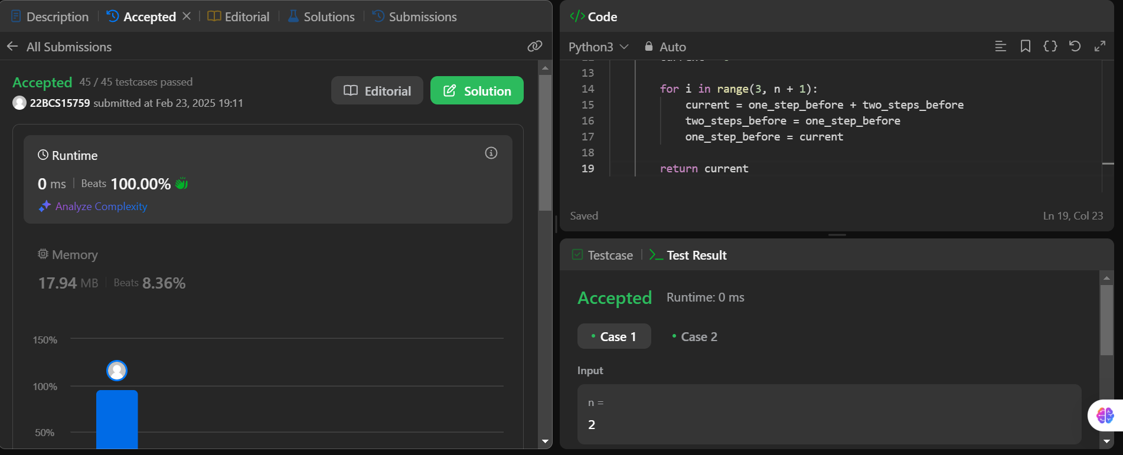

**2.**

**Aim:** You are given an array prices where prices[i] is the price of a given stock on the ith day.

You want to maximize your profit by choosing a single day to buy one stock and choosing a different day in the future to sell that stock.Return the maximum profit you can achieve from this transaction. If you cannot achieve any profit, return 0.

1. **Source Code:**

class Solution:

    def maxProfit(self, prices: List[int]) -> int:

        """

        You are given an array prices where prices[i] is the price of a given stock on the ith day.

        You want to maximize your profit by choosing a single day to buy one stock and choosing a different day in the future to sell that stock.

        Return the maximum profit you can achieve from this transaction. If you cannot achieve any profit, return 0.

        """

        if not prices:

            return 0

        min_price = prices[0]

        max_profit = 0

        for price in prices:

            min_price = min(min_price, price)

            max_profit = max(max_profit, price - min_price)

        return max_profit

1. **outputs:**

